### Welcome to Pilot Grove Savings Bank!

**We are pleased to have you join our growing customer family.**

*Pilot Grove Savings Bank has been proud to call Southeast Iowa home since opening its doors more than a century ago in the small town of Pilot Grove, Iowa. Our deep roots in the region have allowed us to understand the unique needs of our communities, and year after year, we’ve committed ourselves to serving them better. With the acquisition of Wayland State Bank, we’re eager to extend our reach and connect even more with the members of our community. As we embark on this new chapter, we are excited to get to know you. We invite you to take the opportunity to discover more about us. Visit our main office and branch locations to experience firsthand our exceptional service. Explore our website, ask us questions, and see how Pilot Grove Savings Bank can be your trusted financial partner. We are Pilot Grove Savings Bank, and we are here to serve you.*

As you may be aware, Pilot Grove Savings Bank has recently signed an agreement with Wayland State Bank, facilitating the acquisition of their assets and facilities in Wayland, Winfield, and Mount Pleasant. **The acquisition and following conversion are expected to occur following the close of business on Friday, July 12, 2024. On Monday, July 15, 2024, the offices will open as Pilot Grove Savings Bank.**

While we understand you may be unfamiliar with the procedures of an acquisition, we wish to reassure you our Bank team has been working hard to ensure you will experience a smooth transition to the Pilot Grove Savings Bank family. Our acquisition of Wayland State Bank represents a positive step forward for all of us – one that will provide an even stronger position in product and service leadership along with greater resource availability. We are excited to introduce you to our long-standing reputation of trust and stability in addition to our strong commitment to Southeast Iowa.

At Pilot Grove Savings Bank you will experience competitive rates, friendly personal service, specifically designed products, and services to meet your financial needs, and much, much more. We hope you will discover that at Pilot Grove Savings Bank a working relationship is much more than cashing a check, opening a savings account, or having a vehicle loan. It’s a two-way street we can travel together for a very long time. We look forward to being your financial partner and working with you for many years to come.

Matt Morrison President/CEO

# Our Promise to You

#### Trust. Loyalty. Commitment.

When you bank with us at Pilot Grove Savings Bank, there are three important things you can always count on – trust, loyalty, and commitment. These are the qualities long-lasting meaningful relationships are built around, in banking and in life. They are words and feelings that define the foundation of the working relationship we hope to develop with each customer and proudly carry forward from generation to generation.

At Pilot Grove Savings Bank, our commitment to our community runs deep. For over a hundred years, we’ve proudly served as trusted partners to our friends and neighbors throughout Southeast Iowa and beyond. Our journey together has been one of mutual support and collaboration. From financing homes to facilitating investments, from funding small businesses to assisting with agricultural endeavors, we’ve worked hand in hand with our customers to realize their goals and aspirations. Beyond financial transactions, our relationships have blossomed into true friendships grounded in shared values and a collective dedication to building stronger, more vibrant communities. Together, we’ve laid the groundwork for a brighter future, enriching lives, and enhancing the quality of life for generations to come.

We are very proud to offer the same trust, loyalty, and commitment to each and every one of our customers today as we did when we opened our doors in 1911. Our promise through the years has given our customers the confidence and assurance to rely on, and our bank a firm foundation to build on. With customer loyalty on our side and more than a century of banking experience, Pilot Grove Savings Bank remains strong as one of Southeast Iowa’s oldest and most trusted banking institutions.

***Welcome to Pilot Grove Savings Bank.***

## History of Pilot Grove Savings Bank

Pilot Grove Savings Bank was established on May 12, 1911. Twenty-three investors pooled a total of $10,000 to start the Bank and set up business in a small building on the western side of the only street in Pilot Grove, Iowa. Since that day, the Bank has continued to grow and prosper, serving customers in the Bank’s Southeast Iowa area as well as many other locations across the country.

In 1951, the original structure was expanded. In 1962, the Bank virtually doubled in size as an additional wing was added to the facility. The structure was presumably completed 21 years later in 1983, with a second additional wing on the south side of the building. In 2007, construction again began on the main bank in Pilot Grove, this time with an addition to the building’s north end. While the original Pilot Grove building has continued to expand over the decades, the institution itself has grown with the addition of branch offices in ten neighboring towns. Houghton (1980), Donnellson (1983), West Point (1992), Mount Pleasant and

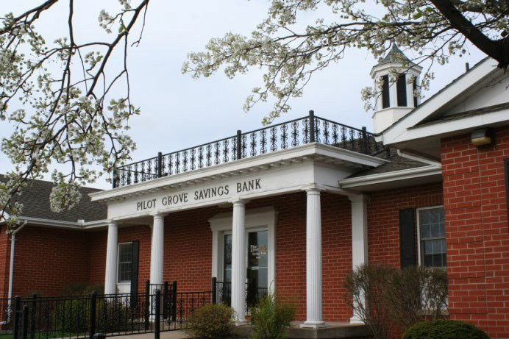

Packwood (2000), Winfield (2004), Fort Madison (2011), Keokuk (2013), Fairfield (2014), and West Burlington (2020). Today, with over 100 employees, Pilot Grove Savings Bank remains steadfast in its founding values of trust, loyalty, and commitment, poised to embark on a new chapter through this merger with Wayland State Bank.

# Important Information

### Wayland State Bank / Pilot Grove Savings Bank Conversion

##### Conversion Date

On Friday, July 12, 2024, at 4:00 P.M., Wayland State Bank branches will close to begin the conversion process, and remain closed until Monday, July 15, 2024, when branches will reopen as Pilot Grove Savings Bank.

No worries! You will have access to your Wayland State Bank funds throughout the conversion process. You will be able to write checks and use your debit card just like normal.

##### Checking and Savings Account Conversion

Your checking and savings accounts will transfer to Pilot Grove Savings Bank exactly as they were at Wayland State Bank. Please refer to the enclosed account disclosures and the *Frequently Asked Questions* for more information. If, after the conversion, you have questions or wish to make changes to your accounts, please visit with any of our account representatives.

##### Automatic Deposits and Payments

All ACH (Automated Clearing House) transactions will continue to post to your new Pilot Grove Savings Account as usual. However, for all new ACH requests after the July 12, 2024, conversion date please provide your vendor with the following updated information:

Routing Number: 073916668

Address: Pilot Grove Savings Bank 1341 Pilot Grove Rd Pilot Grove, IA 52648

Phone Number: 319-469-3951

##### Checking and Savings Account Statements

Wayland State Bank will provide you with a statement reflecting transactions and balances through the close of business on Friday, July 12, 2024. The first Pilot Grove Savings Bank statement you receive after the conversion will reflect your ending balance with Wayland State Bank at the close of business on July 12, 2024, and the activity of your account at Pilot Grove Savings Bank. Your statement will be mailed to your address of record following our first regular statement cycle.

##### eStatements

Enjoy the safety and convenience of eStatements, an electronic form of statement delivery. Inquire at any Pilot Grove Savings Bank location about signing up for eStatements or visit our website at [www.pilotgrovesavingsbank.com](http://www.pilotgrovesavingsbank.com/).

##### Check Images

Your Pilot Grove Savings Bank monthly statements will contain digital check images of paid checks and deposit slips. A three-ring binder to keep your account statements organized will be provided to all account holders upon request.

##### Information about Our Business Day

It is important for you to understand the Pilot Grove Savings Bank Business Day. Take time to review the following information. Please share your questions with any Pilot Grove Savings Bank representative.

***4:00 p.m. – Business Day Ends***

Although the bank is open until 5:00 p.m. Monday through Friday, any transaction that occurs after 4:00 p.m. each day is considered the next day’s business. On Friday, any transaction after 4:00 p.m. goes on the following Monday’s business.